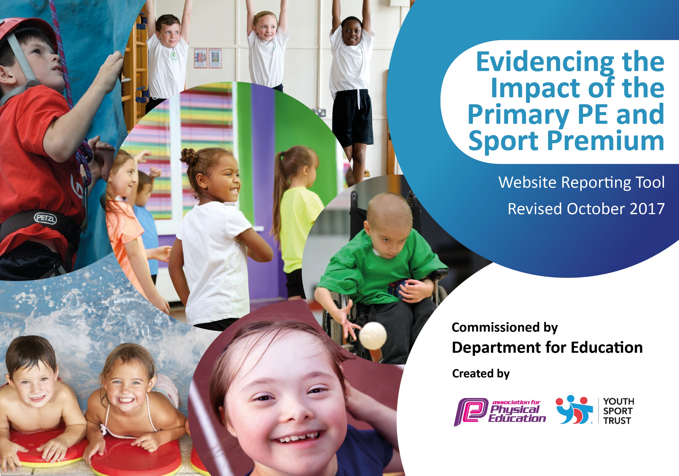

Schools must use the funding to make additional and sustainable improvements to the quality of PE and sport they offer. This means that you should use the Primary PE and Sport Premium to:

- develop or add to the PE and sport activities that your school already offers
- build capacity and capability within the school to ensure that improvements made now will benefit pupils joining the school in future years

Please visit gov.uk for the revised DfE guidance including the 5 key indicators across which schools should demonstrate an improvement. This document will help you to review your provision and to report your spend. DfE encourages schools to use this template as an effective way of meeting the reporting requirements of the Primary PE and Sport Premium.

We recommend you start by reflecting on the impact of current provision and reviewing the previous spend.
Under the Ofsted Schools Inspection Framework, inspectors will assess how effectively leaders use
the Primary PE and Sport Premium and measure its impact on outcomes for pupils, and how effectively governors hold them to account
for this.

Schools are required to publish details of how they spend this funding as well as on the impact it has on pupils’ PE
and sport participation and attainment.
We recommend regularly updating the table and
publishing it on your website as evidence
of your ongoing review into how you are using the money
to secure maximum, sustainable impact. To see an example of how to complete the table please click HERE.

Support for review and reflection - considering the 5 key indicators from DfE, what development needs are a priority for your setting and your students now and why? Use the space below to reflect on previous spend, identify current need and priorities for the future.

Key achievements to date: | Areas for further improvement and baseline evidence of need:
Biodome has been purchased in order to provide a legacy for the school with the P.E. and Sport Premium. The Bio dome will enable us to teach and promote how to have, and to maintain, a healthy lifestyle to the whole school community.  Children given a voice that is heard and now have a pivotal role in decisions that are made around physical activity and sport offered at the school.  Profile of physical activity is raised and now part of organised daily routines in the classroom and outside. Competitive sport is a frequent occurrence between the trust’s schools, in the form of the RMET cup | Ensuring all children meet all of the swimming National Curriculum has been identified as an area for development. Plans put in place so that children have swimming lessons in three different year groups.  Not enough children participate in competitive sports or attend sport clubs, as identified by student questionnaires. More free sports club to be offered by the school, including clubs run by RMGS students. School to participate in more sporting competitions, including KS1 events.

Meeting national curriculum requirements for swimming and water safety | Please complete all of the below:  *Results are currently assessed by parents. Children’s swimming ability will be assessed against the objectives in term 6 and published before the end of the academic year 17/18.
What percentage of your Year 6 pupils could swim competently, confidently and proficiently over a distance of at least 25 metres when they left your primary school at the end of last academic year? |  | 34.78%*
What percentage of your Year 6 pupils could use a range of strokes effectively [for example, front crawl, backstroke and breaststroke] when they left your primary school at the end of last academic year? |  | 34.78%*
What percentage of your Year 6 pupils could perform safe self-rescue in different water-based situations when they left your primary school at the end of last academic year? |  | 26.08%*
Schools can choose to use the Primary PE and Sport Premium to provide additional provision for swimming but this must be for activity over and above the national curriculum requirements. Have you used it in this way? |  | No

Action Plan and Budget Tracking
Capture your intended annual spend against the 5 key indicators. Clarify the success criteria and evidence of impact that you intend to measure to evaluate for students today and for the future.

Academic Year: 2017/18 | Total fund allocated: £ | Date Updated:
Key indicator 1: The engagement of all pupils in regular physical activity – Chief Medical Officer guidelines recommend that primary school children undertake at least 30 minutes of physical activity a day in school |  |  |  | Percentage of total allocation:
 |  |  |  | 88.8%
School focus with clarity on intended impact on pupils: | Actions to achieve: | Funding allocated: | Evidence and impact: | Sustainability and suggested next steps:
Children are aware of the benefits of regular physical activity and how important a healthy lifestyle is and what all the components are.  Children enjoy organised physical activity as part of break and lunch times.  Children are given a voice and responsibility about what the school does in regard to physical activity and promoting it.  Children enjoy physical activity in the classroom and as part of other core subjects. | - Biodome to be fitted onto school grounds that can accommodates 33 student in the outdoor learning environment. Enables us to grow our own produce to then use in variety of curriculum areas in our fully equipped classroom ‘Cookery Corner’. Enables school to continue to develop its healthy lifestyle whole school approach and tackle current childhood obesity issues. Offers life skills to children and parents and develops our creative curriculum.  - Fitness day assembly and visit from Ben Smith (401 challenge)  - Fit4Kids day workshops  - Sport and Physical activity focused assemblies.  - Year 5 targeted for ‘Tiger Troops’ programme annually.  - The importance and effect of physical exercise are embedded in PSHE and Science lessons.  - Sport relief promoted within school and 15,000 minutes of exercise achieved.  - Change4life club run and targeted at Year 3 and 4 pupils who are reluctant movers or do not have access to sport clubs outside of school.  - Play leaders have been trained by HSSP to organise games and activities for children to take part in at break and lunch times.  - Children take part in the daily march.  - The whole school, including staff, take part in a whole school warm up on a Friday afternoon.  - Sport Council has been set up and children trained by HSSP in different roles. Termly meetings take place and children have ownership on projects they take part in.  - Children have daily exercise routines in the classroom (5-a-day).  - Sport/fitness based maths meetings.  - Maths and English exercise/dance rountines (BBC Supermovers) | £14,940 (Total cost £16,500)  £600 | All year groups to be actively using the facilities.  The resource will be embedded into all areas of the curriculum.  Its usage will be monitored to ensure it is being used to its potential.  Setting dreams and ambitions. Children know the importance of exercise but how fun, powerful and enjoyable it can be.  Children are taught by experts on how important exercise is, are inspired and motivated to be more active, increase their daily exercise both in and outside of school.  Given home and lunch time fitness ideas.  Know importance of physical activity.  Promotes physical activity to whole school community.  Uninterested or reluctant movers are participating and enjoying sport.  Increased physical exercise during break and lunch times led by children.  Increased physical activity.  Increased physical activity for all the whole school, showing exercise is fun and involves everyone.  Children created display board, competitions and reported on sport matches, including on website and newsletter.  Promoting and increasing daily exercise  Promoting and increasing daily exercise | Biodome to be a legacy at the school and enable us to grow our own food, cook it and eat it. This will involve the whole school community, especially involving children and parent participation.  Review of how the bio dome could be used further, in all areas of the curriculum.  Further fitness/exercise/sport visits/workshops.  To cover relevant and changing topics relating to Sport and exercise each year.  To continue each year.  To take part in Chnage4life festival  Play leader to be changed and new play leaders to be trained by current play leaders.  Some children to progress to jogging.  Explore possibility of extra day.  Children to have active role in the Bio dome set up and how it is used.  Other projects to be explored.  Explore how exercise can be incorporated in other ways during the school day.
Key indicator 2: The profile of PE and sport being raised across the school as a tool for whole school improvement |  |  |  | Percentage of total allocation:
 |  |  |  | 0%
School focus with clarity on intended impact on pupils: | Actions to achieve: | Funding allocated: | Evidence and impact: | Sustainability and suggested next steps:
Children given a voice and their opinions heard and acted upon.  P.E is an important part of the curriculum.  Children offered sport clubs and take part in competitive sport.  The majority of children meet the national curriculum swimming targets. | Sports Council set up to provide student voice and express opinions of their peers.  P.E. surveys completed to find out what they enjoy; what areas of P.E they feel confident in; participation outside of school; what sports/clubs they would like to take part in etc.  Children have a minimum of 2 hours organised P.E/physical activity teaching time per week.  Cross-curricula links are frequently made.  KS2 Football club.  KS1 multi-sports club  Change4lifeclub  Year 3 and 4 RMET Sports club termly competition  Sports club to be run by RMGS students  It is planned for children to have a block of swimming lessons in year 2, 4 and 6 to ensure children leave primary school with a good level of swimming competency. |  | Termly meetings occur and self-determined projects set up.  Data helps to inform future decisions in a variety of areas.  To be monitored regularly.  Pupil questionnaires to shows increased participation in sports clubs and competitive sport.  Children to be assessed regularly against National Curriculum objectives in both year groups. | Children to be given increasing responsibility for a variety of issues and causes.  Good practice to be shared with school and trust.  To continue to increase the amount sports clubs the school offers.  Swimming to be taught in three year groups to ensure 100% of children meet national curriculum targets.

Key indicator 3: Increased confidence, knowledge and skills of all staff in teaching PE and sport |  |  |  | Percentage of total allocation:
 |  |  |  | 9.25%
School focus with clarity on intended  impact on pupils: | Actions to achieve: | Funding  allocated: | Evidence and impact: | Sustainability and suggested  next steps:
Staff are more confident teaching a wider range of sports.  P.E lessons show progression of skills taught across the year groups.  Staff are able to accurately assess the progress of children.  P.E. lead to complete PESS level 5 | Staff are surveyed to highlight any areas for development or CPD.  P.E training on gymnastics by HSSP and future CPD to be run by the RMET.  New sport focused planning scheme bought to run alongside skill based planning.  OTrack used to assess P.E in line with the school assessment policy.  P.E. lead will be able to offer CPD to other teachers at the school. | £420  £1,200 | CPD to be offered to on how to maximise space, ensure safety, offer variety when using the school hall and gymnastics.  Staff are able to use a range of resources and equipment to improve their confidence in teaching a variety of different sports.  Assessment can be done instantly, all year group objectives can be accessed, all in the same space.  Can address our own CPD needs. | Questionnaire to be done annually  After a whole year of use, the impact and staff opinion will be sought to inform if we continue our subscription.  Used for all subjects, across all year groups.  P.E. lead will be able to use future data from staff questionnaires to address CPD needs.
Key indicator 4: Broader experience of a range of sports and activities offered to all pupils |  |  |  | Percentage of total allocation:
 |  |  |  | 2.05%
School focus with clarity on intended  impact on pupils: | Actions to achieve: | Funding  allocated: | Evidence and impact: | Sustainability and suggested  next steps:
Additional achievements:  Children experience a wider range of sports across year groups.  Children are offered sports that interest and appeal to them.  Children are able to access sport based extra curricula activities. | New scheme bought to provide planning for a wider range of sports.  Children surveyed to find out what sports they would like to be taught during P.E lessons.  Yoga to be taught to two year groups by specialist teacher.  KS2 Football club offered.  KS1 multi-sports club to be offered  Change4lifeclub  Year 3 and 4 RMET Sports club termly competition  Sports clubs??????  Sports club run by RMGS students  SEND sports club to be offered to targeted children at the school. | As previously stated  £360 | 12 different themes/sports taught to each year group, from plans that ensure progression and differentiation.  Questionnaire has highlighted sports children want to learn and participate in.  More children will participate in sport clubs and competitive sports, including SEND pupils. | Monitored and reviewed annually.  School to teach hockey and rugby in KS2.
Key indicator 5: Increased participation in competitive sport |  |  |  | Percentage of total allocation:
 |  |  |  | 0%
School focus with clarity on intended  impact on pupils: | Actions to achieve: | Funding  allocated: | Evidence and impact: | Sustainability and suggested  next steps:
More children will participate in competitive sports. | Pupils surveyed to assess how many children participate in sport inside and outside of school.  Year 3 and 4 have entered into the RMET sports cup and play termly matches in a wide variety of sports. |  | Has highlighted the need to involve more children in competitive sport and at an earlier age.  Increase in % of children, in year 3 and 4, participating in competitive sport already increasing. | Enter into a Year 3/4 School football league.  Further competitive sporting opportunities to be explored  Pupils to be surveyed on an annual basis to record % of children taking part in competitive sport.  KS1 sports competition set up within trust.

