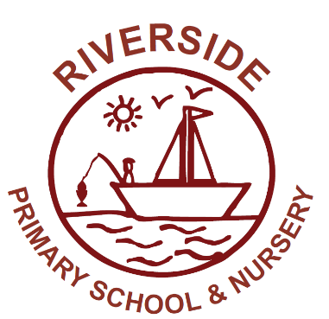
Riverside Primary School & Nursery
St Edmund’s Way
Rainham
Gillingham
Kent ME8 8ET
www.riverside.medway.sch.uk
Telephone: 01634 338700
Email: office@riverside.medway.sch.uk

Headteacher: Mrs Kim Wilmer
Wednesday 26th May 2021

Dear Parents/Carers,

We are writing to advise you that in Term 6 children from Y1 to Y6 will be looking at the topic of ‘Changing Me’ using the Jigsaw PSHE scheme of work that we have adapted to suit our school. Jigsaw is a spiral, progressive and effective scheme of work, aiming to prepare children for life, helping them really know and value who they are and understand how they relate to other people in this ever-changing world.
For more information on the Jigsaw scheme, please visit the website: www.jigsawpshe.com/

The ‘Changing Me’ puzzle unit is all about coping positively with changes within the human body and all lessons are taught using correct terminology, child-friendly language and diagrams. It is now a statutory requirement to talk about puberty in school and the Jigsaw scheme we use in school supports this. The discussions we have in these lessons are important for your child to be a part of, as they are able to receive the correct age-related information in a safe and secure environment. The lessons build on content and vocabulary taught each year to ensure progression and understanding of the topics taught.

All topics are taught sensitively and are appropriate for the children at their age and stage of development, using common experiences such as a new baby in the family.
Below is a summary of the lesson focuses and key vocabulary in Year 4.

Year Group | Focus of Lessons | Key Vocabulary
Year 4 | - I understand that some of my personal characteristics have come from my birth parents.  - I can describe how a girl’s body changes in order for her to be able to have babies when she is an adult, and that menstruation (having periods) is a natural part of this.  - I understand the importance of personal hygiene during puberty.  - I know how the circle of change works and can apply it to changes I want to make in my life.  - I can identify changes that have been and may continue to be outside of my control that I learnt to accept.  - I can identify what I am looking forward to  when I move to a new class. | New vocabulary that will be taught continuing from previous year groups:  - Unique  - Characteristics  - Ovum/Ova  - Menstruation  - Periods  - Hygiene  - Self-confidence  - Body odour  - Sanitary towels  - Tampons

If you require further information about the content including a copy of the scheme of work then please contact your class teacher. You are also welcome to view the materials used, should you wish to. We believe that our programme deals with these topics sensitively and is in line with the statutory guidance.

Yours sincerely

Miss L Tullett
PSHE Subject Lead

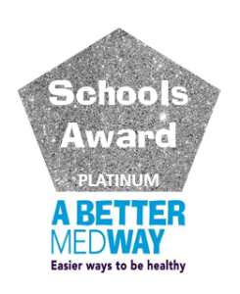
This School is committed to safeguarding and promoting the welfare of children,
achieving equal opportunities and combating discrimination.

Please find attached a list of key vocabulary covered by each year group.

Year Groups | Key  Vocabulary
Year 1 | - Life cycle  - Baby  - Adulthood  - Mature  - Change  - Penis  - Testicles  - Vagina  - Love  - Relationships  - Family  - Marriage  - Community  - Male  - Female  - Feelings  - Emotions
Year 2 | New vocabulary that will be taught continuing from previous year groups:  - Grow  - Control  - Respect  - Appearance  - Physical  - Independent  - Timeline  - Freedom  - Responsibilities  - Anus  - Public  - Private  - Touch  - Texture  - Cuddle  - Hug  - Squeeze  - Acceptable  - Unacceptable  - Comfortable  - Uncomfortable
Year 3 | New vocabulary that will be taught continuing from previous year groups:  - Uterus  - Womb  - Nutrients  - Survive  - Love  - Affection  - Care  - Puberty  - Ovaries  - Egg  - Stereotypes  - Challenge
Year 4 | New vocabulary that will be taught continuing from previous year groups:  - Unique  - Characteristics  - Ovum/Ova  - Making love  - Fertilise  - Reproduction  - Menstruation  - Periods  - Hygiene  - Self-confidence  - Body odour  - Sanitary towels  - Tampons
Year 5 | New vocabulary that will be taught continuing from previous year groups:  - Self-image  - Body image  - Self-esteem  - Perception  - Affirmation  - Relationships  - Conception  - Sexual intercourse  - Fallopian tubes  - Fertilisation  - Pregnancy  - Embryo  - Oestrogen  - Umbilical cord  - Sperm  - Semen  - Contraception  - Testes  - Fertility treatment (IVF)  - Erection  - Ejaculation  - Wet dream  - Larynx  - Facial hair  - Responsibilities  - Growth spurt  - Hormones
Year 6 | New vocabulary that will be taught continuing from previous year groups:  - Foetus  - Contractions  - Grown up  - Real self  - Celebrity  - Placenta  - Cervix  - Attraction  - Trust  - Trust  - Midwife  - Sexting  - Labour  - Pubic hair  - Voice breaks  - Growing taller  - Hips widen  - Breasts  - Ovulation  - Masturbation  - Clitoris  - Vulva

