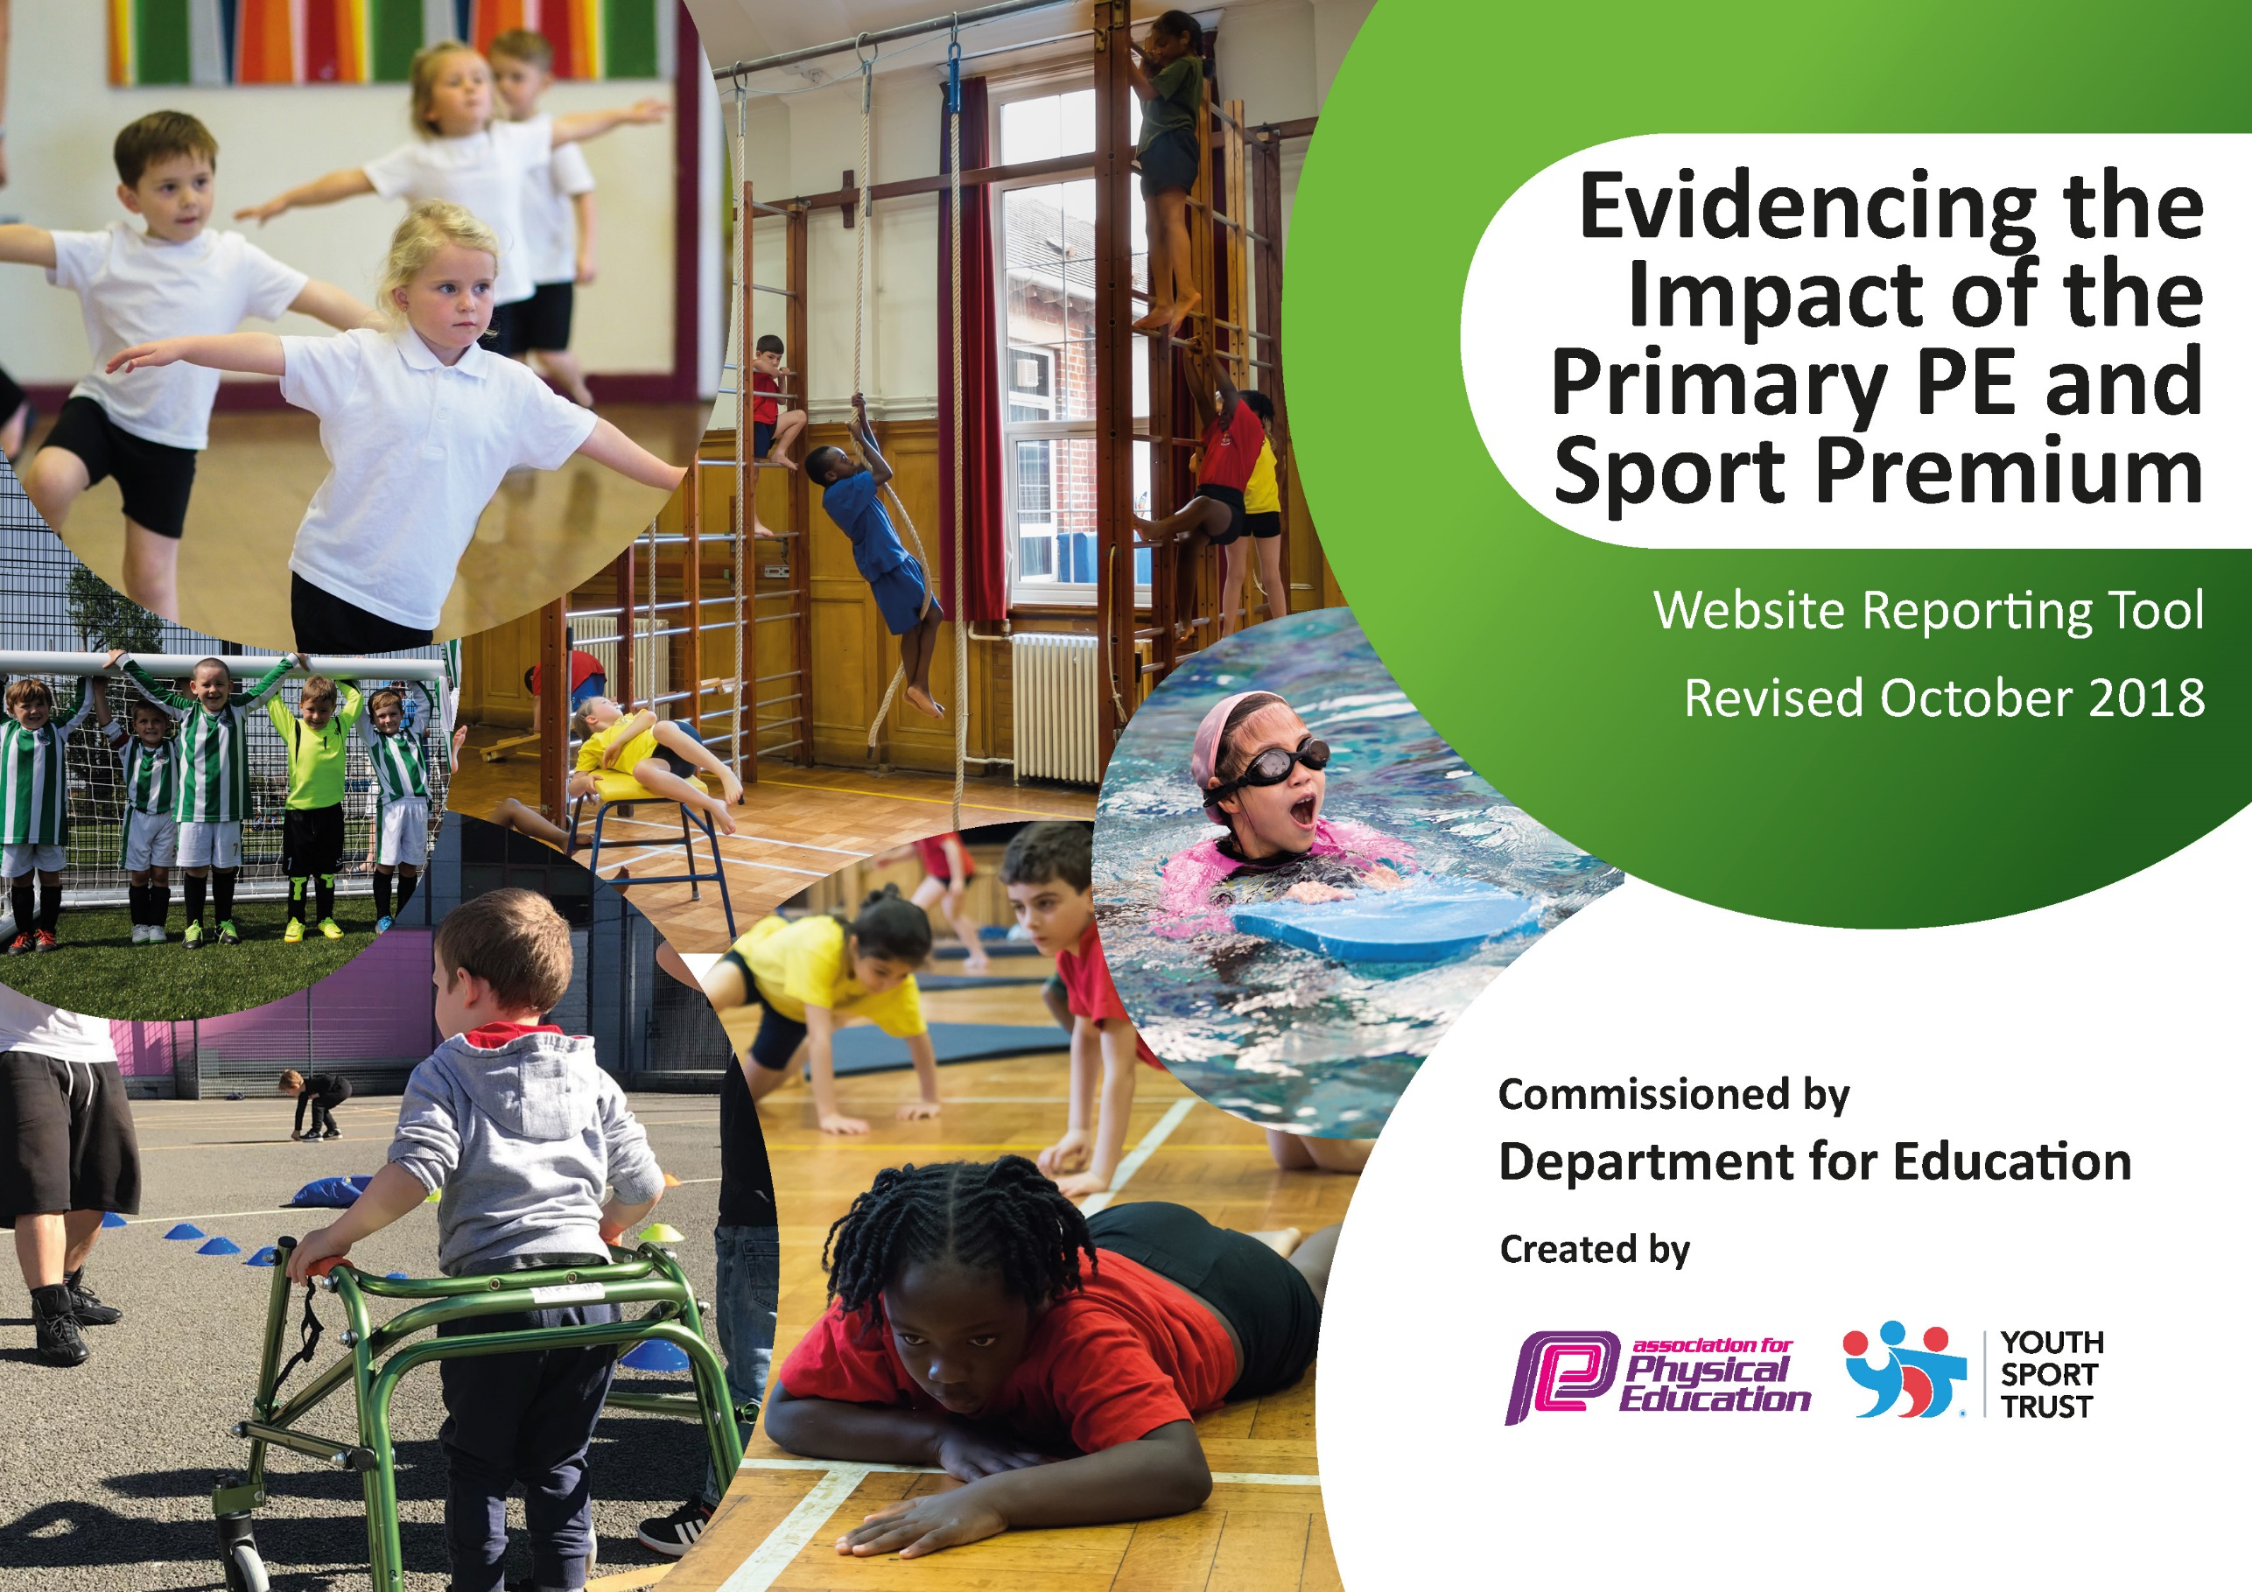
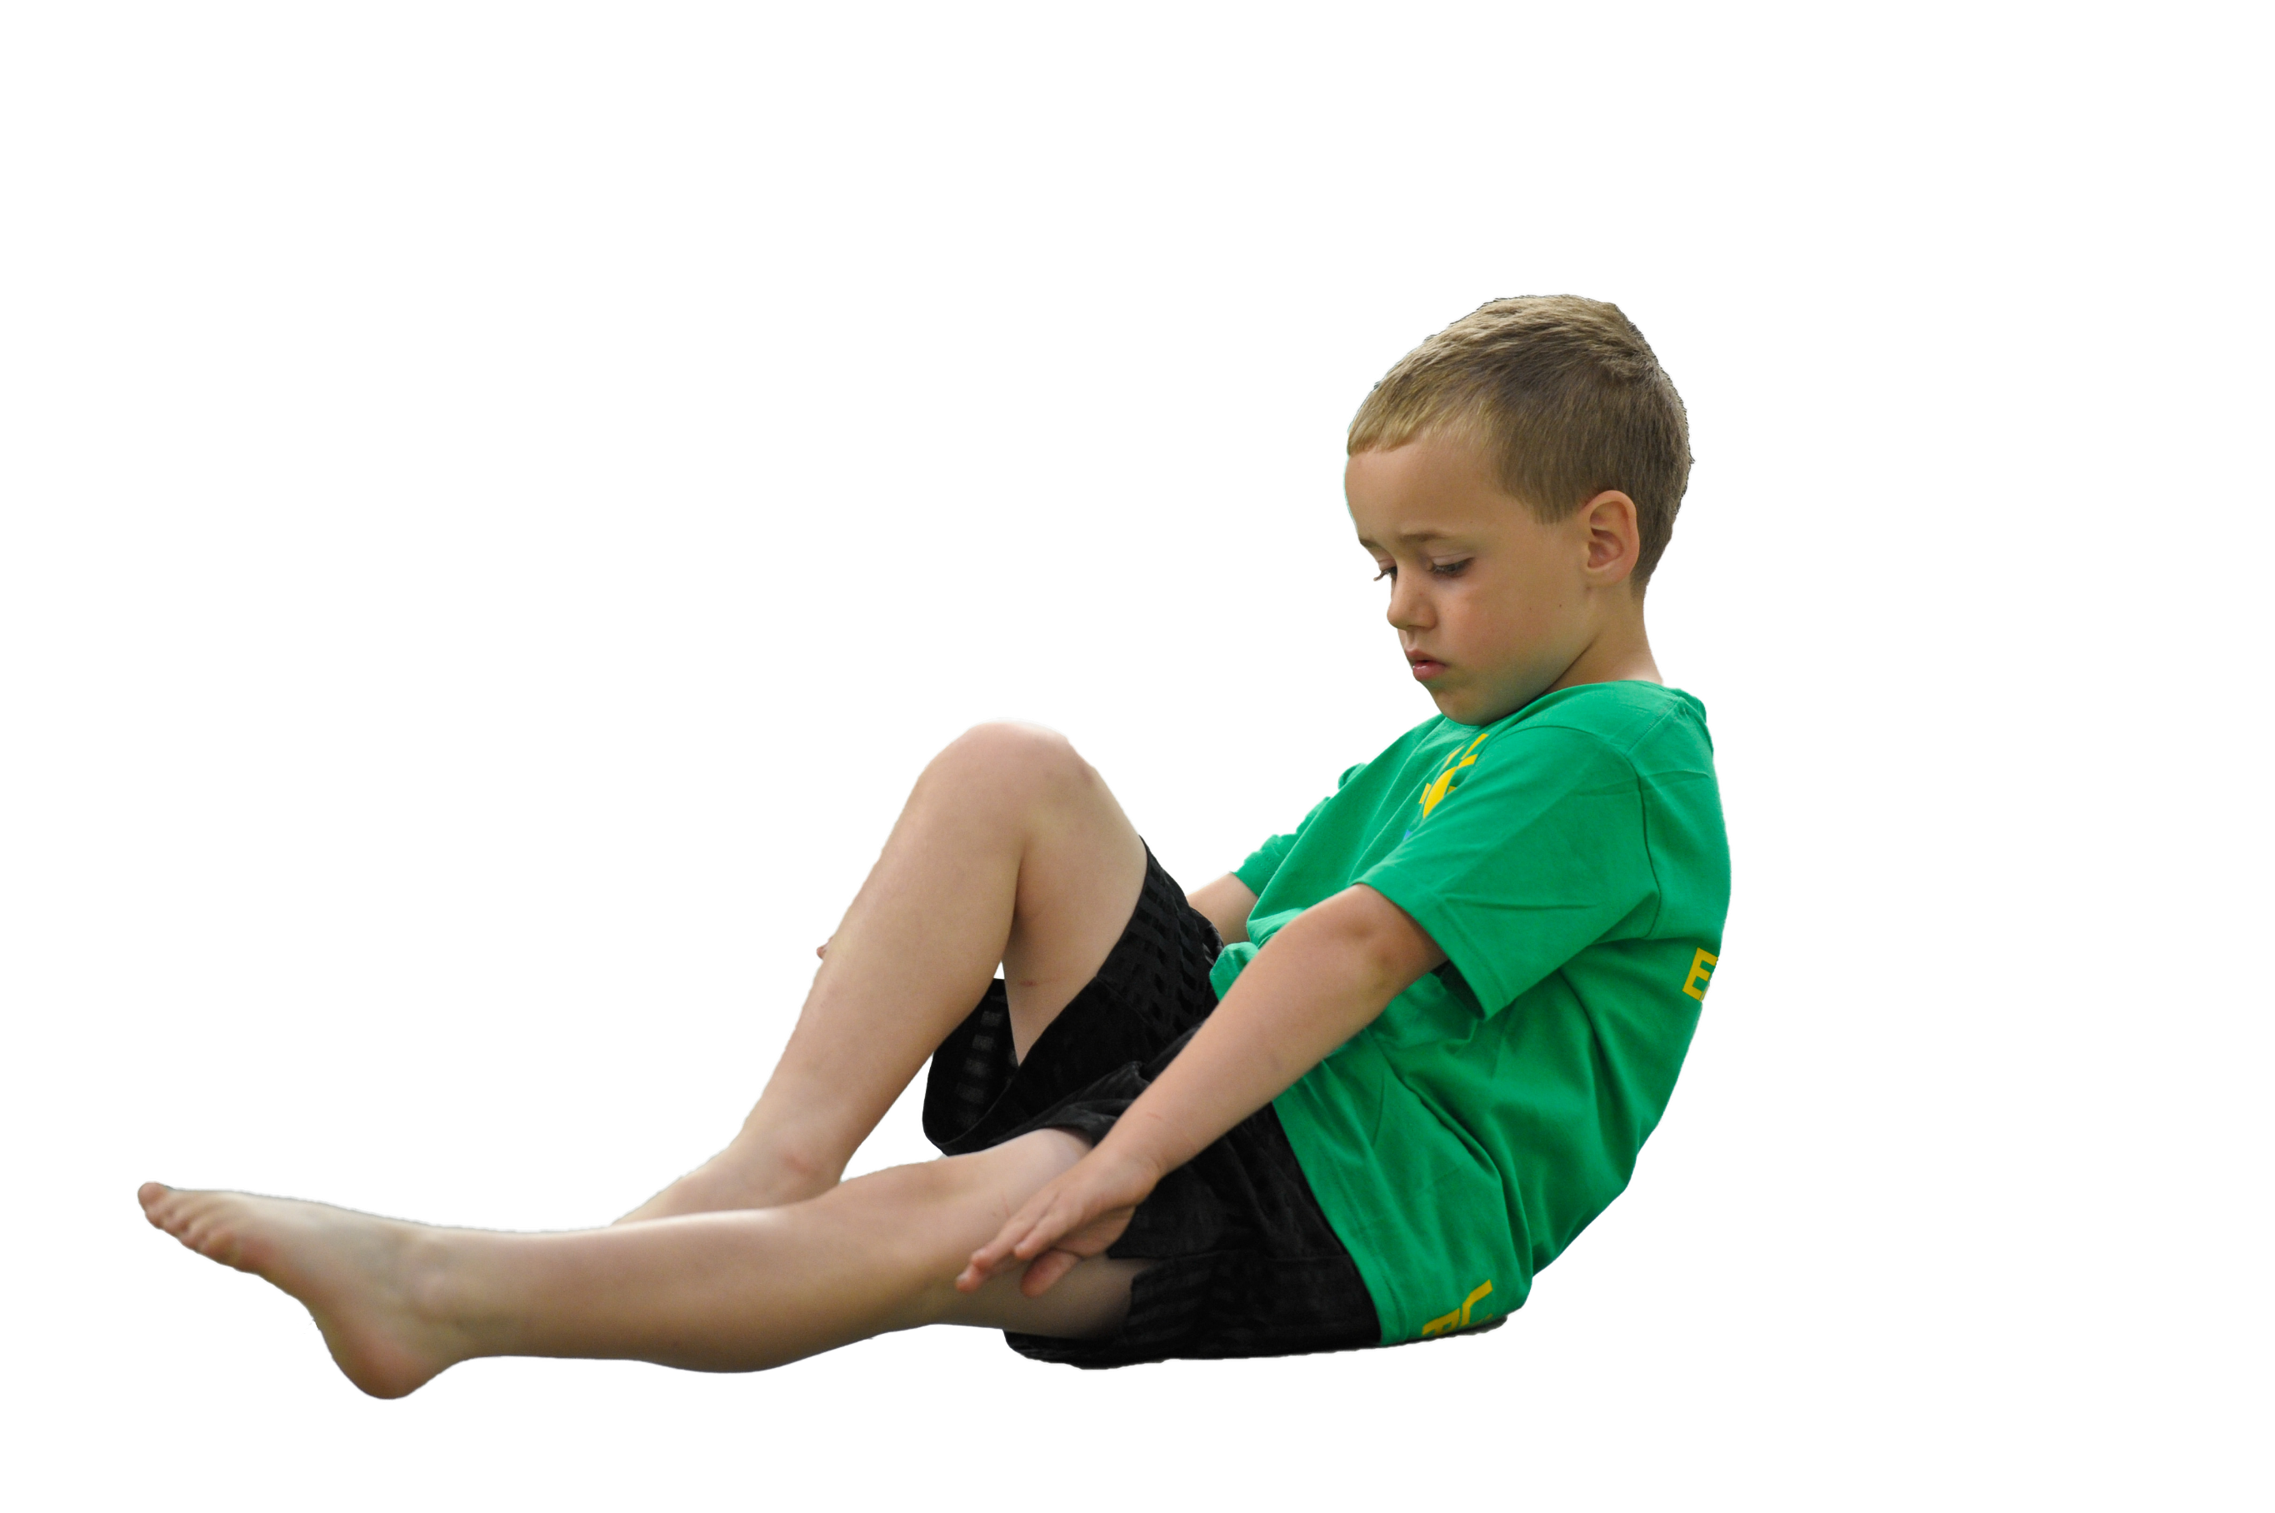
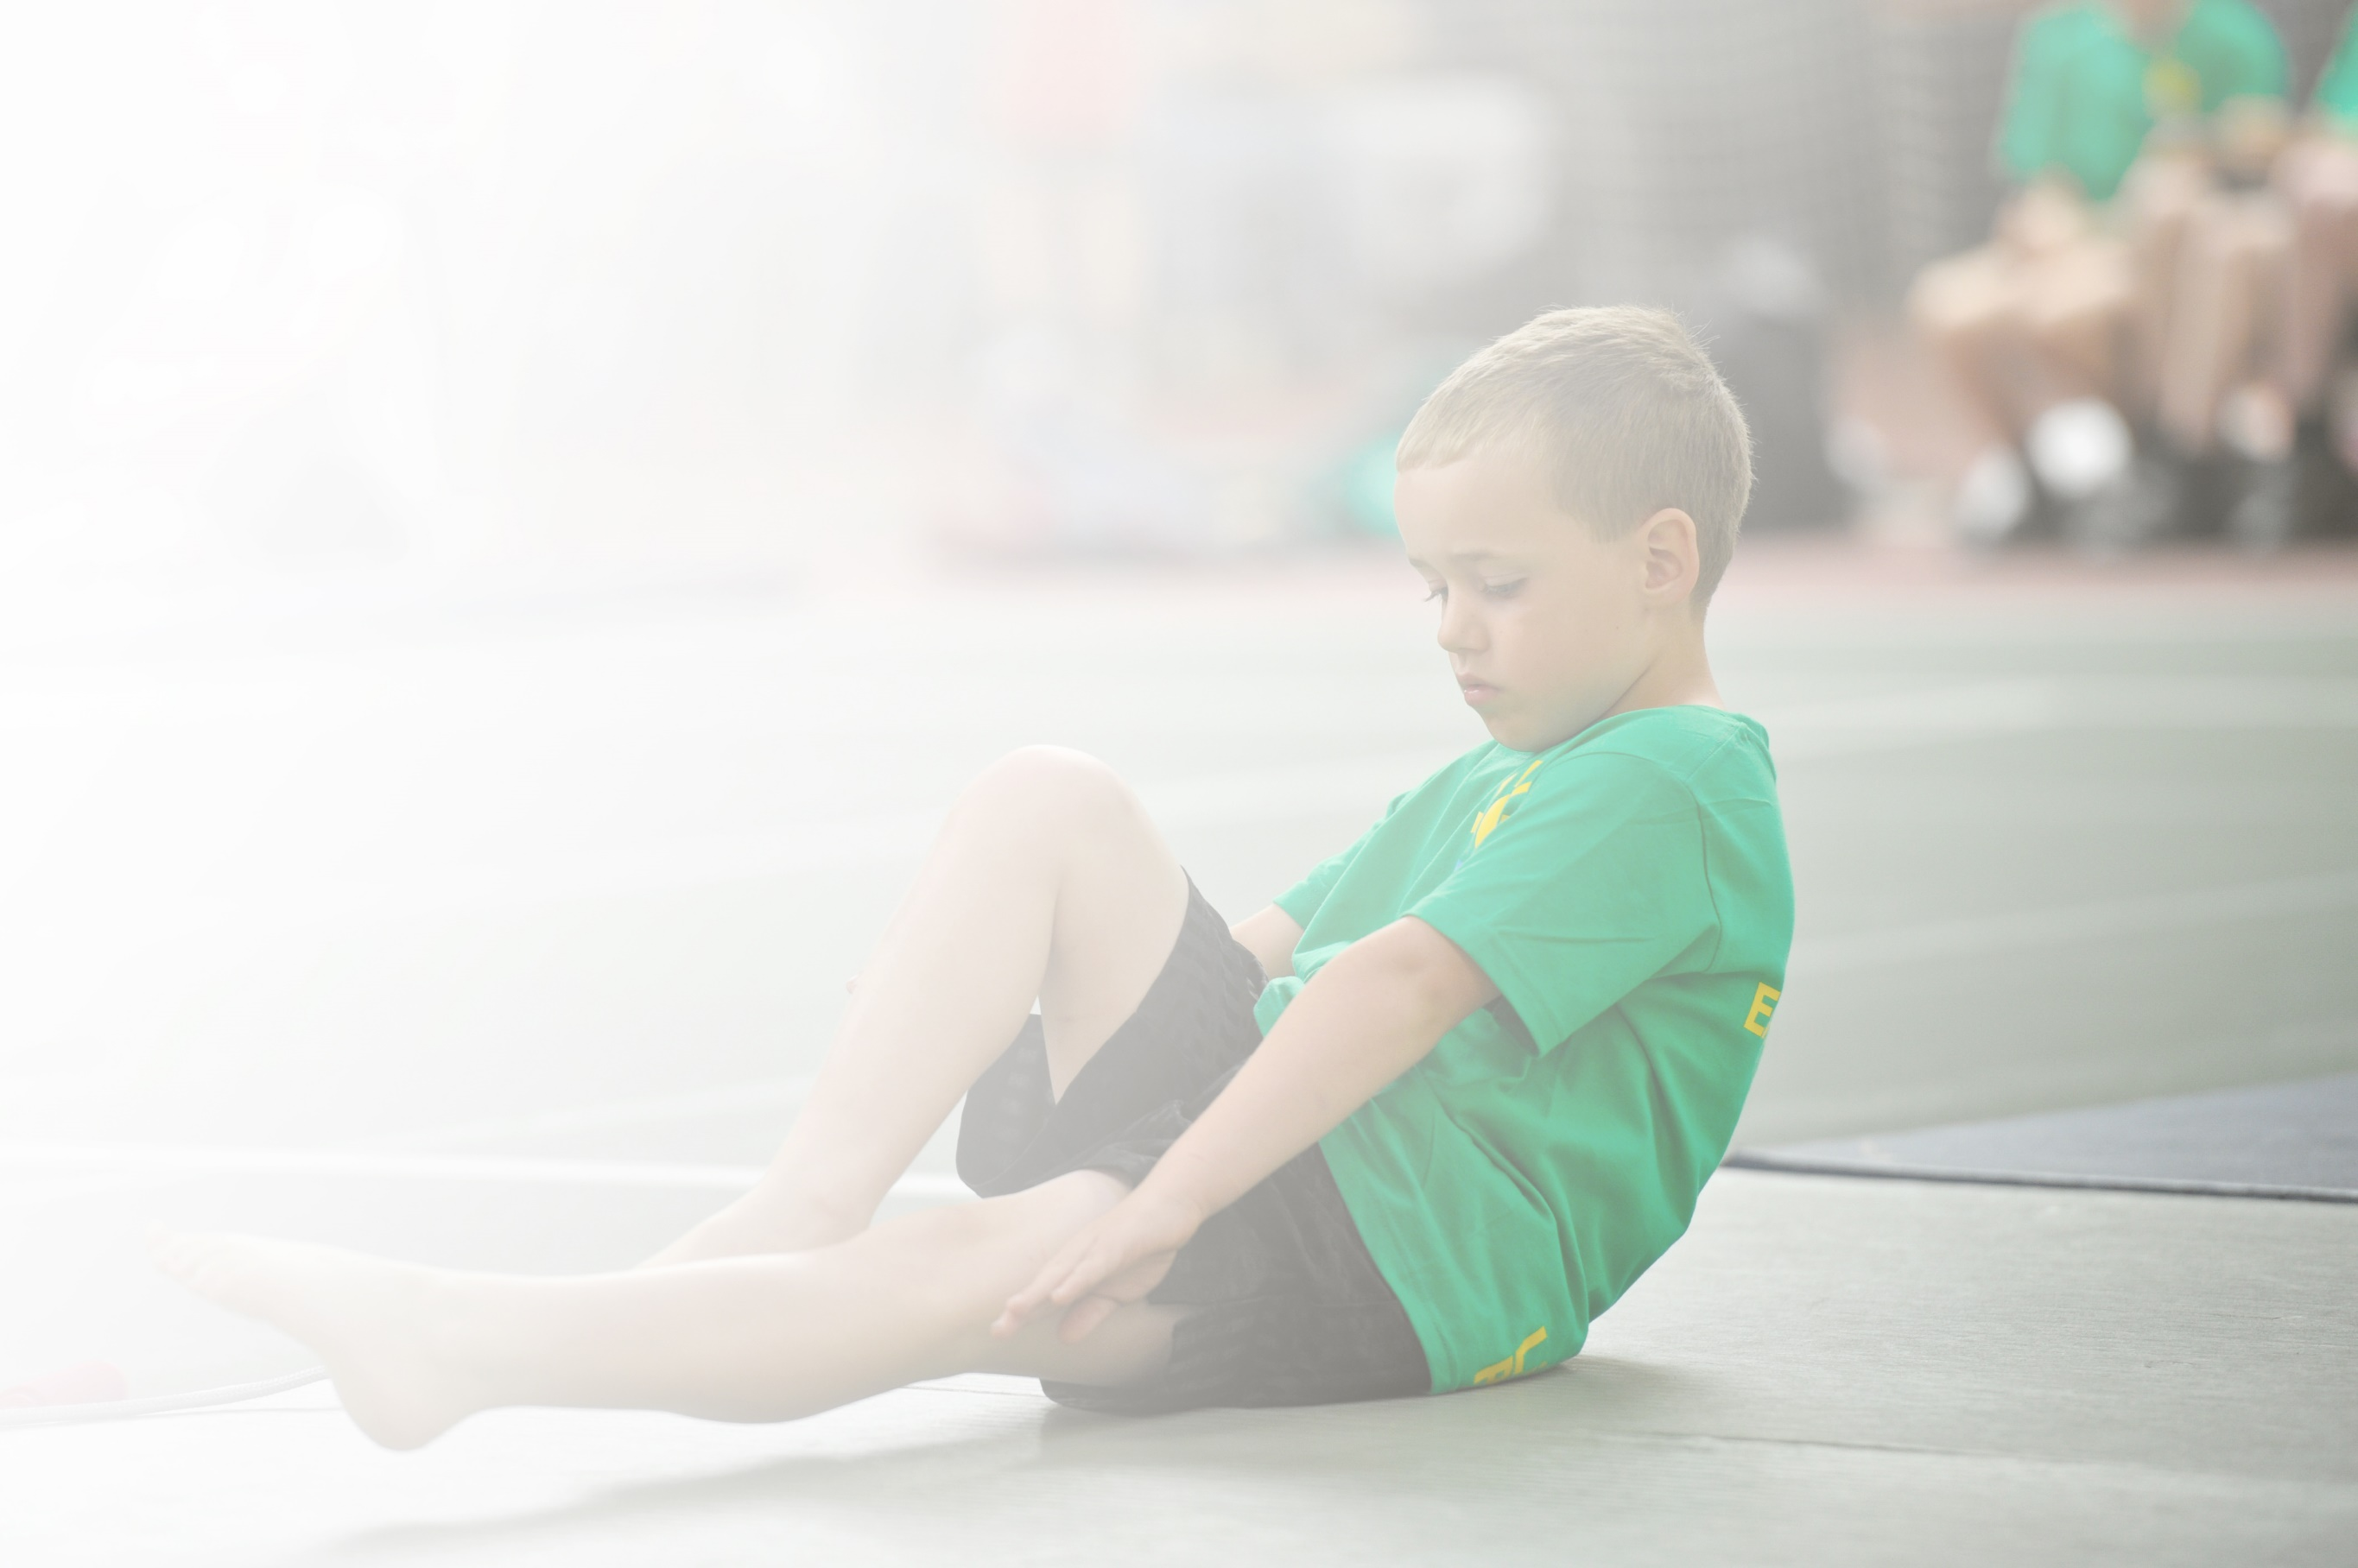
Schools must use the funding to make additional and sustainable improvements to the quality of Physical Education, Sport and Physical Activity (PESPA) they offer. This means that you should use the Primary PE and Sport Premium to:

- Develop or add to the PESPA activities that your school already offer
- Build capacity and capability within the school to ensure that improvements made now will benefit pupils joining the school in future years

Please visit gov.uk for the revised DfE guidance including the 5 key indicators across which schools should demonstrate an improvement. This document will help you to review your provision and to report
your spend. DfE encourages schools to use this template as an effective way of meeting the reporting requirements of the Primary PE and Sport Premium.

We recommend you start by reflecting on the impact of current provision and reviewing the previous
spend. Under the Ofsted Schools Inspection Framework, inspectors will assess how effectively leaders use the Primary PE and Sport Premium and measure its impact on outcomes for pupils, and how effectively governors hold them to account for this.

Schools are required to publish details of how they spend this funding as well as on the impact it has on pupils’ PE and sport participation and attainment by the end of the summer term or by 31 July 2019 at the
latest.
We recommend regularly updating the table and publishing it
on your website throughout the year, as evidence of your
ongoing review into how you are using the money to
secure maximum, sustainable impact. To see an
example of how to complete the table please
click HERE.

Support for review and reflection - considering the 5 key indicators from DfE, what development needs are a priority for your setting and your students now and why? Use the space below to reflect on previous spend, identify current need and priorities for the future.

Key achievements to date: | Areas for further improvement and baseline evidence of need:
The biodome, which was purchased with last year’s premium, is embedded into the curriculum and is producing fruit and vegetables that the children can cook with and also eat in the school salad and fruit bar.  Exercise equipment, playground markings and table tennis tables have been purchased to increase the amount of physical activity at break and lunchtimes. Providing different equipment gives the children more opportunities to have fun while exercising and help them meet the 30 minutes of exercise at school.  PPG children have been targeted to participate in sport competitions to ensure they are given the opportunity to participate (they may have limited experience outside of school). Reluctant PE participants and SEND have attended Sports club to inspire and motivate them to engage in different sports and physical activity.  PESSPA training for HLTA to continue upskilling staff so that they can share best practice and improve the confidence of staff teaching PE and improve the quality of PE lessons at the school. | Improve the offering of sports clubs to children. Clubs are run by school but not many are sport clubs. This will give children further opportunity to participate in sport and physical activity and increase the amount of physical activity completed at school.  More children have engaged in competitions this year, but this is still an area for the school to improve. Children in year’s 5 and 6 to be targeted to play in a variety of sports.  The school’s swimming data has significantly improved this year and more children are confident in the water, can swim 25m and know how to stay safe. RNLI have supported the school to promote water safety this year. Swimming to continue to be a focus and improve data year-on-year.

Meeting national curriculum requirements for swimming and water safety | Please complete all of the below:
What percentage of your current Year 6 cohort swim competently, confidently and proficiently over a distance of at least 25 metres?  N.B. Even though your children may swim in another year please report on their attainment on leaving  primary school. | 77%
What percentage of your current Year 6 cohort use a range of strokes effectively [for example, front crawl, backstroke and breaststroke]? | 69%
What percentage of your current Year 6 cohort perform safe self-rescue in different water-based situations? | 74%
Schools can choose to use the Primary PE and Sport Premium to provide additional provision for swimming but this must be for activity over and above the national curriculum requirements. Have you used it in this way? | No

Action Plan and Budget Tracking
Capture your intended annual spend against the 5 key indicators. Clarify the success criteria and evidence of impact that you intend to measure to evaluate for students today and for the future.

Academic Year: 2018/19 | Total fund allocated: £17,000 | Date Updated: 1/7/19
Key indicator 1: The engagement of all pupils in regular physical activity – Chief Medical Officer guidelines recommend that primary school children undertake at least 30 minutes of physical activity a day in school |  |  |  | Percentage of total allocation:
 |  |  |  | 87.94%
Intention: | Implement: | Funding allocated: | Evidence and impact: | Sustainability and suggested next steps:
Inspire the children to engage regularly in physical activity | Invest in outdoor gym equipment which can be used at break and lunchtime.  Staff model how this can be used and train Sports Leaders to supervise and promote use.  Invest in outdoor Table Tennis tables for playground.  FirefighterFitKids – launch sessions with classes and subscription.  Playground markings  Current markings to be gone over. New game squares, maze and trail to be added. | £9,999  £1,500  £450  £3000 | Equipment now in place and all chn shown how to use the equipment safely.  Rota in place.  Equipment being used on a daily basis at break and lunch.  Increased physical activity on the playground.  Used as a reward each week for well-behaved classes.  Equipment will provide a different sport to be played at break and lunch o promote physical activity  All teachers have access to fitness videos and resources.  HP runs an exercise club three times a week.  New playground markings will other children opportunities to be active during break and lunchtime. | Chn will be surveyed on their opinions of the equipment in the next academic year.  Usage to be looked at and the equipment promoted if necessary.  Table tennis tables still to be put in.  Staff are using the resources.  20-30 children attend the exercise club (each session).  Playground leaders to be taught how to use the markings and to use in their organised activities.
Key indicator 2: The profile of PESSPA being raised across the school as a tool for whole school improvement |  |  |  | Percentage of total allocation:
 |  |  |  | 3.67%
School focus with clarity on intended impact on pupils: | Actions to achieve: | Funding allocated: | Evidence and impact: | Sustainability and suggested next steps:
Disseminate best practice in PE through whole school training.  Develop whole school language and practices for PE.  Introduce new sport/activities to appeal to all. | Introduce PE progression skills.  PE star words for each year group.  Whole-school common language.  HP and EF to share best practice from PESSPA course to the rest of the staff.  Yoga equipment bought. Yoga introduced during Healthy Living week. | £0  £650 | Star words introduced and used to support the children’s learning and progress.  Common language being used in some classes and has utilised the lesson time and reduced low level behaviour.  PE progression skills introduced and staff ensure their lessons follow these.  Yoga to be part of the PE offer next year to all classes. To inspire children to participate in a different type of activity and to motivate girls to participate in more physical activity. | Common language needs to be introduced to the whole school.  Whole school training to be delivered by HP and EF next year.

Key indicator 3: Increased confidence, knowledge and skills of all staff in teaching PE and sport |  |  |  | Percentage of total allocation:
 |  |  |  | 6.79%
School focus with clarity on intended  impact on pupils: | Actions to achieve: | Funding  allocated: | Evidence and impact: | Sustainability and suggested  next steps:
PPA covered PE lessons are of a high standard and HLTA has the confidence, knowledge and skills to deliver PE objectives to a high standard.  HLTA models best practice to others | HLTA undertaking PESSPA Level 5 | £1,200 | HLTA using and developing new knowledge and skills with different year groups.  PE lead is working with HLTA and team teaching to develop skills. | HLTA able to work with PE lead to deliver school CPD (planned for 2019).  Competitive/performance aspect in each topic across all year groups and review lesson format.
Key indicator 4: Broader experience of a range of sports and activities offered to all pupils |  |  |  | Percentage of total allocation:
 |  |  |  | 2.82%
School focus with clarity on intended  impact on pupils: | Actions to achieve: | Funding  allocated: | Evidence and impact: | Sustainability and suggested  next steps:
Additional achievements:  SEND children and reluctant PE participants engage in extra-curricular sports and activities. Sports offered are different, appeal and accessible to all. | Lunchtime sports club run by Medway Sport to target SEND and reluctant participants in KS2 (term 2) and FS and KS1 (term 6). | £500 | Club enjoyed by all, well attended and all children achieved. | Further clubs to be run by school staff to engage ALL children at lunchtimes, enabling children who are by taxi to participate.
Key indicator 5: Increased participation in competitive sport |  |  |  | Percentage of total allocation:
 |  |  |  | 1.13%
School focus with clarity on intended  impact on pupils: | Actions to achieve: | Funding  allocated: | Evidence and impact: | Sustainability and suggested  next steps:
Increased participation or access to competitive games and sport for PPG children. | Y1+2 and Y3+4 to attend multi-skills festival. All children selected were PPG (where possible). | £200 | Children were able to compete in a variety of multi-skill events and achieve. All children earned bronze or silver certificates and two children earned Endeavour awards. | School to attend festival every year targeting children who don’t have many sporting opportunities outside of school.

